Задание

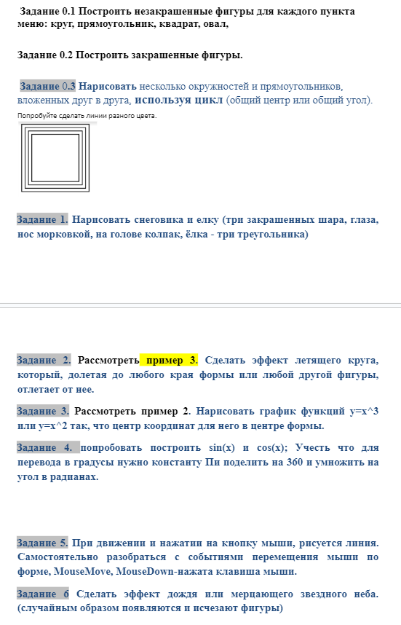

Код программы :

﻿using System;

using System.Collections.Generic;

using System.ComponentModel;

using System.Data;

using System.Drawing;

using System.Linq;

using System.Text;

using System.Threading;

using System.Threading.Tasks;

using System.Windows.Forms;

namespace WindowsFormsApp3

{

public partial class Form1 : Form

{

public Form1()

{

InitializeComponent();

}

private void Form1_Load(object sender, EventArgs e)

{

}

Pen bluePen = new Pen(Color.Blue, 4.5f);

Pen redPen = new Pen(Color.Red, 4.5f);

Pen greenPen = new Pen(Color.Green, 4.5f);

private void линияToolStripMenuItem_Click(object sender, EventArgs e)

{

Graphics g = this.CreateGraphics();

g.DrawLine(bluePen, 10, 31, 816, 458);

g.DrawLine(redPen, 0, 458, 816, 10);

g.Dispose();

}

private void очиститьВсеToolStripMenuItem_Click(object sender, EventArgs e)

{

Graphics g = this.CreateGraphics();

g.Clear(Color.WhiteSmoke);

g.Dispose();

}

private void прямоугольникToolStripMenuItem_Click(object sender, EventArgs e)

{

Graphics g = this.CreateGraphics();

g.DrawRectangle(bluePen, 300, 170,100,200);

g.DrawRectangle(greenPen, 500, 200, 100, 100);

g.FillRectangle(Brushes.Coral, 50, 100, 200, 300);

g.FillRectangle(Brushes.Chocolate, 640, 200, 100, 100);

g.Dispose();

}

private void окружностьToolStripMenuItem_Click(object sender, EventArgs e)

{

Graphics g = this.CreateGraphics();

g.DrawEllipse(bluePen, 500, 200, 100, 100);

g.DrawEllipse(greenPen, 300, 170, 100, 200);

g.FillEllipse(Brushes.DarkBlue, 640, 200, 100, 100);

g.Dispose();

}

private void трапецияToolStripMenuItem_Click(object sender, EventArgs e)

{

Point[] tt = { new Point(100, 120), new Point(180, 120), new Point(260, 230), new Point(90, 230) };

Graphics g = this.CreateGraphics();

g.DrawPolygon(redPen, tt);

g.Dispose();

}

private void треугольникToolStripMenuItem_Click(object sender, EventArgs e)

{

Point[] tt = { new Point(520, 50), new Point(580, 150), new Point(345, 100)};

Graphics g = this.CreateGraphics();

g.DrawPolygon(redPen, tt);

g.Dispose();

}

private void шестиугольникToolStripMenuItem_Click(object sender, EventArgs e)

{

Point[] tt = { new Point(200, 225), new Point(250, 250), new Point(250, 300), new Point(200,325), new Point(150, 300), new Point(150,250) };

Graphics g = this.CreateGraphics();

g.DrawPolygon(redPen, tt);

g.Dispose();

}

private void toolStripMenuItem2_Click(object sender, EventArgs e)

{

Graphics g = this.CreateGraphics();

int a = 500; int b = 200; int c = 100; int d = 100;

for (int i = 0; i< 5; i++)

{

g.DrawRectangle(greenPen, a, b, c, d);

a = a + 10; b = b+10; c = c - 20;d = d - 20;

}

g.Dispose();

}

private void toolStripMenuItem3_Click(object sender, EventArgs e)

{

Graphics g = this.CreateGraphics();

g.FillEllipse(Brushes.Beige, 300, 80, 80, 80);

g.FillEllipse(Brushes.Beige, 290, 160, 100, 100);

g.FillEllipse(Brushes.Beige, 280, 260, 120, 120);

g.FillEllipse(Brushes.Black, 310, 107, 10, 10);

g.FillEllipse(Brushes.Black, 340, 107, 10, 10);

Point[] tt = { new Point(330, 120), new Point(380, 130), new Point(330, 140) };

Point[] tt2 = { new Point(210, 15), new Point(340, 65), new Point(275, 135) };

g.DrawPolygon(redPen, tt2);

g.DrawPolygon(redPen, tt);

Point[] t1 = { new Point(610, 140), new Point(660, 140), new Point(635, 90) };

Point[] t2 = { new Point(610, 170), new Point(660, 170), new Point(635, 120) };

Point[] t3 = { new Point(610, 200), new Point(660, 200), new Point(635, 150) };

g.FillPolygon(Brushes.Green, t1);

g.FillPolygon(Brushes.Green, t2);

g.FillPolygon(Brushes.Green, t3);

g.Dispose();

}

int x = 0, y = 0, x1 = 15, y1 = 15;

private void timer1_Tick(object sender, EventArgs e)

{

Graphics g = this.CreateGraphics();

SolidBrush shar = new SolidBrush(Color.Tomato);

if (x + x1 >= 796)

{

x1 = -x1;

x = x + x1;

}

else x = x + x1;

if (x + x1 < 0) x1 = -x1;

if (y + y1 >= 450)

{

y1 = -y1;

y = y + y1;

}

else y = y + y1;

if (y + y1 < 0) y1 = -y1;

g.FillEllipse(shar,x, y, 10, 10);

Thread.Sleep(50);

g.Clear(Color.WhiteSmoke);

g.Dispose();

}

private void button1_Click(object sender, EventArgs e)

{

timer1.Stop();

}

private void шарToolStripMenuItem_Click(object sender, EventArgs e)

{

timer1.Start();

}

}

}